**Week 4**

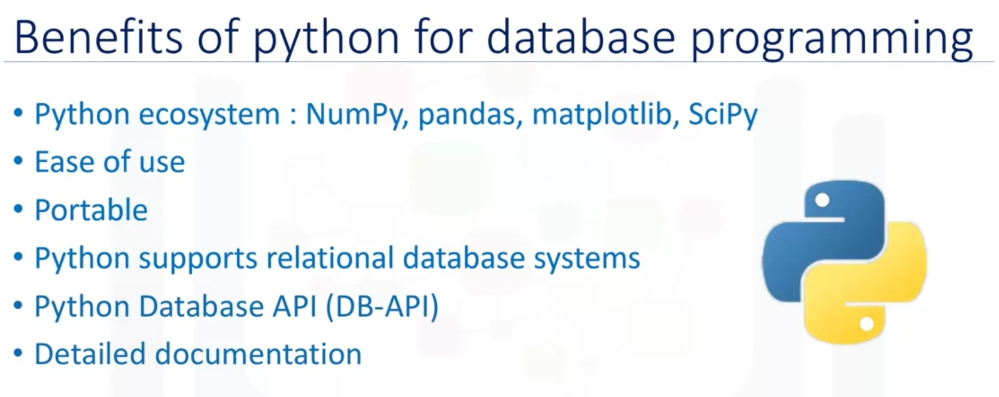

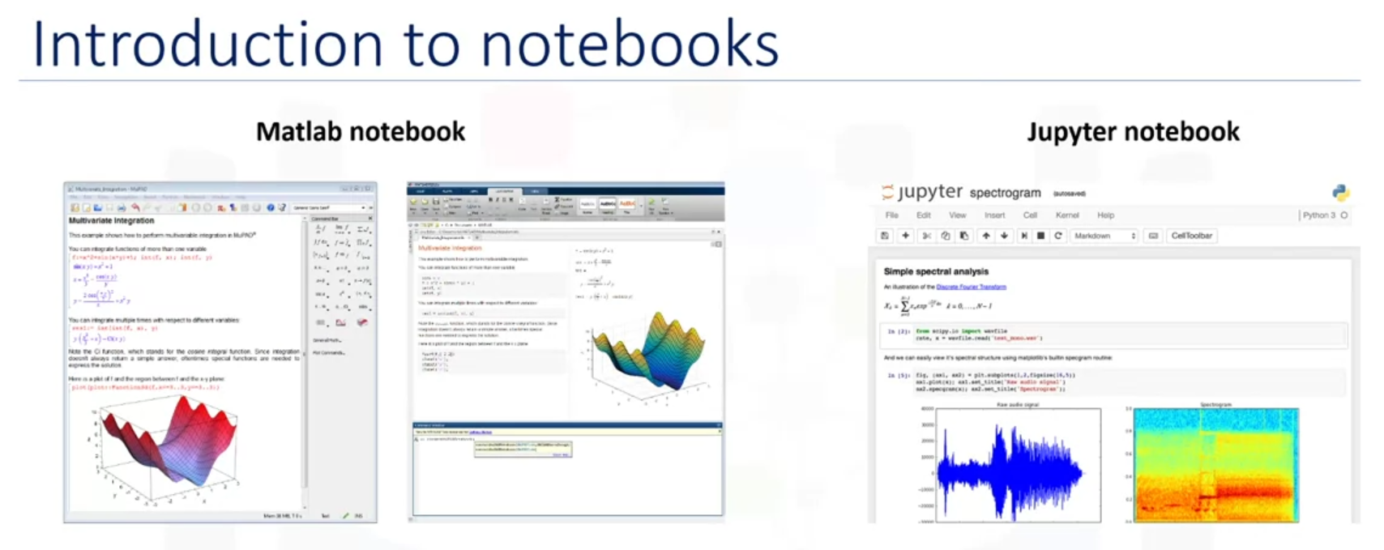

A notebook interface is a virtual notebook environment used for programming. Examples of notebook interfaces include:

* Mathematica notebook
* Maple worksheet
* Matlab notebook
* IPython Jupyter
* R Markdown
* Apache Zeppelin
* Apache Spark notebook
* Databricks cloud

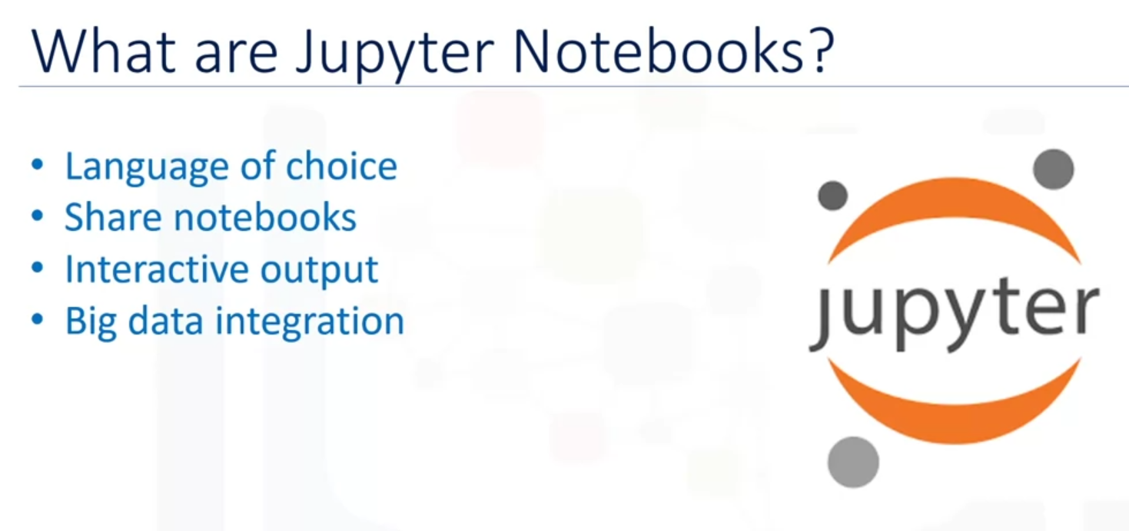

The Jupyter notebook is an open source web application that allows you to create and share documents that contain live code, equations, visualizations, and narrative texts.

Advantages of using Jupyter notebooks:

* Notebook support for over 40 programming languages including Python, R, Julia, and Scala.
* Notebooks can be shared with others by email, Dropbox, GitHub, and the Jupyter notebook viewer.
* Your code can produce rich interactive output HTML, images, videos, LaTex, and customized types.
* You can leverage big data tools such as Apache Spark from Python, R, and Scala, and explore that same data with pandas, scikit-learn, ggplot2, and TensorFlow.

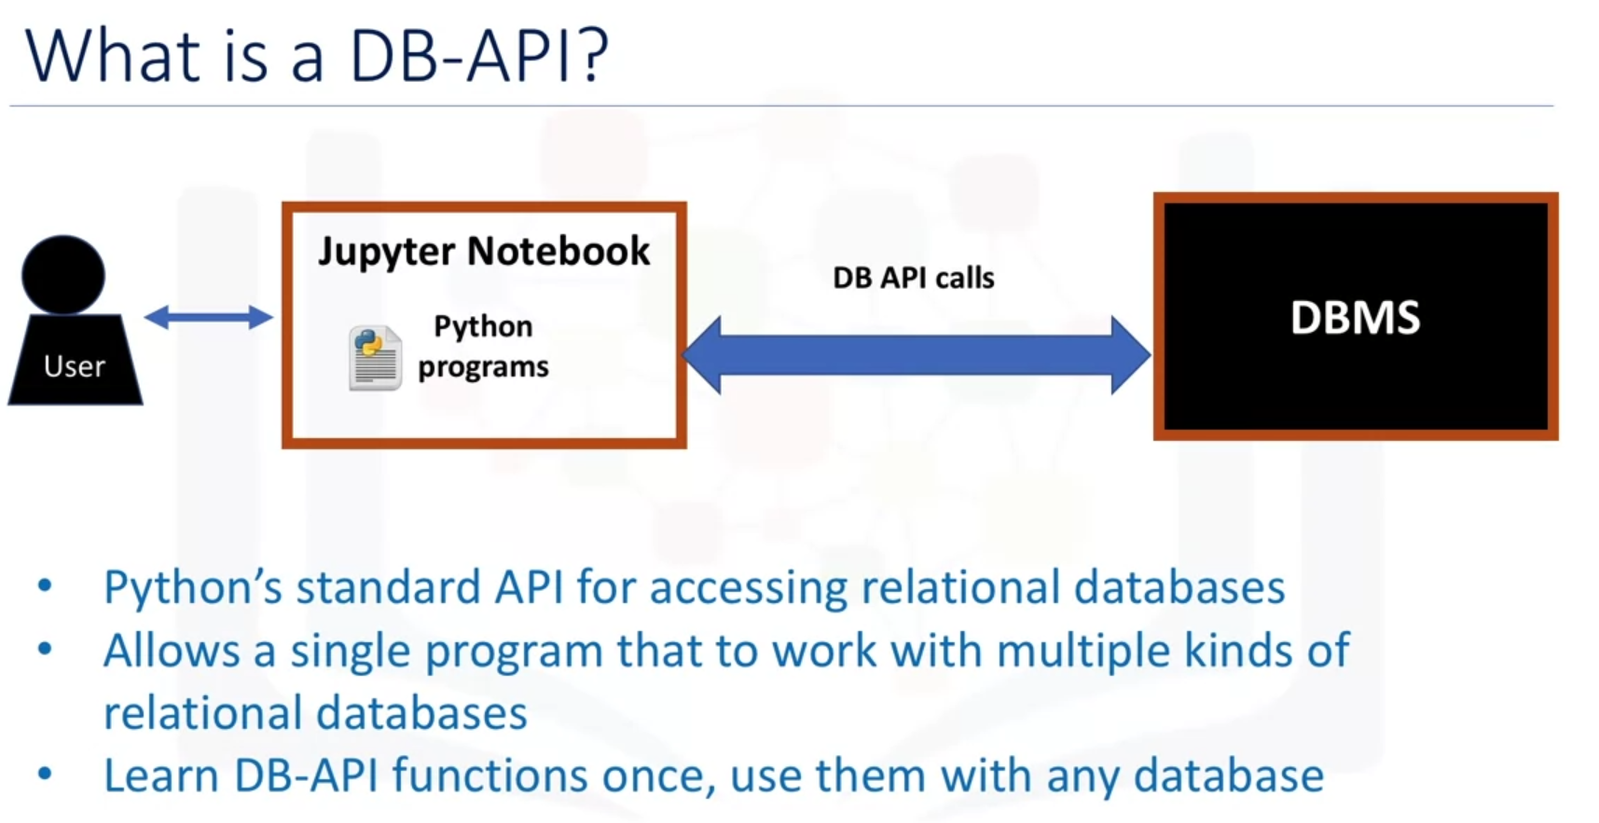

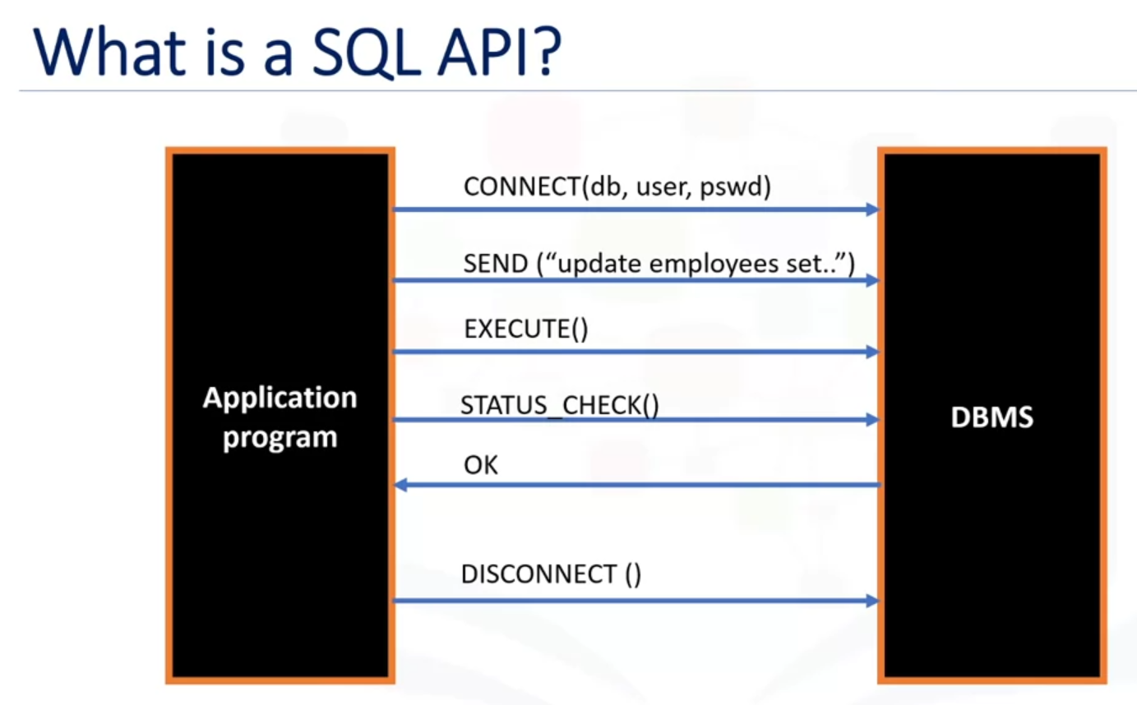

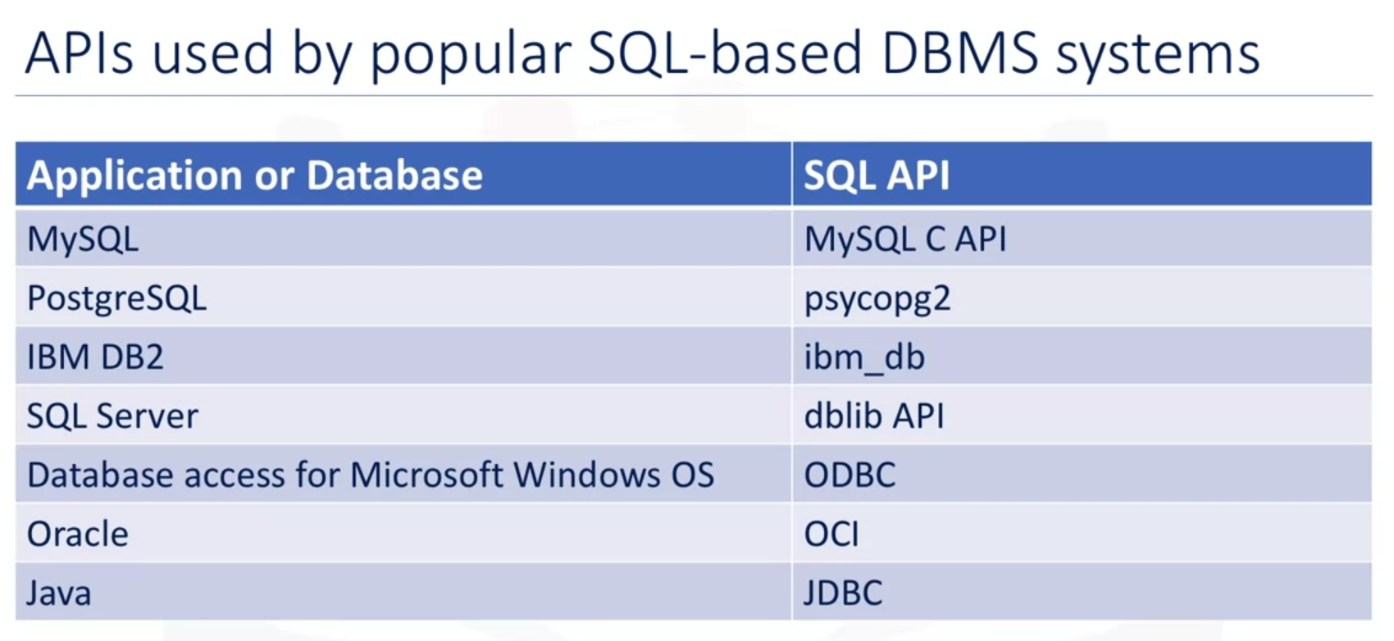

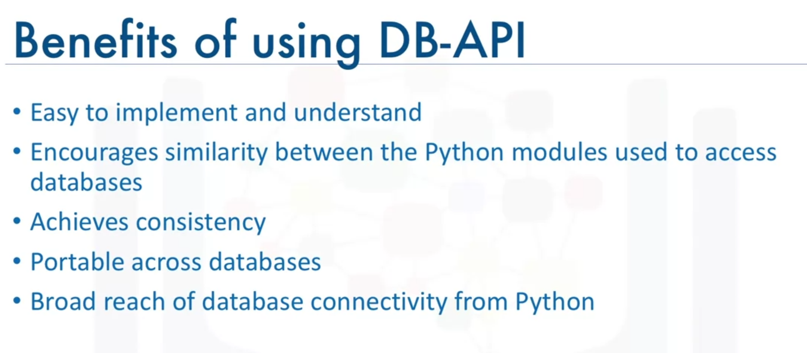

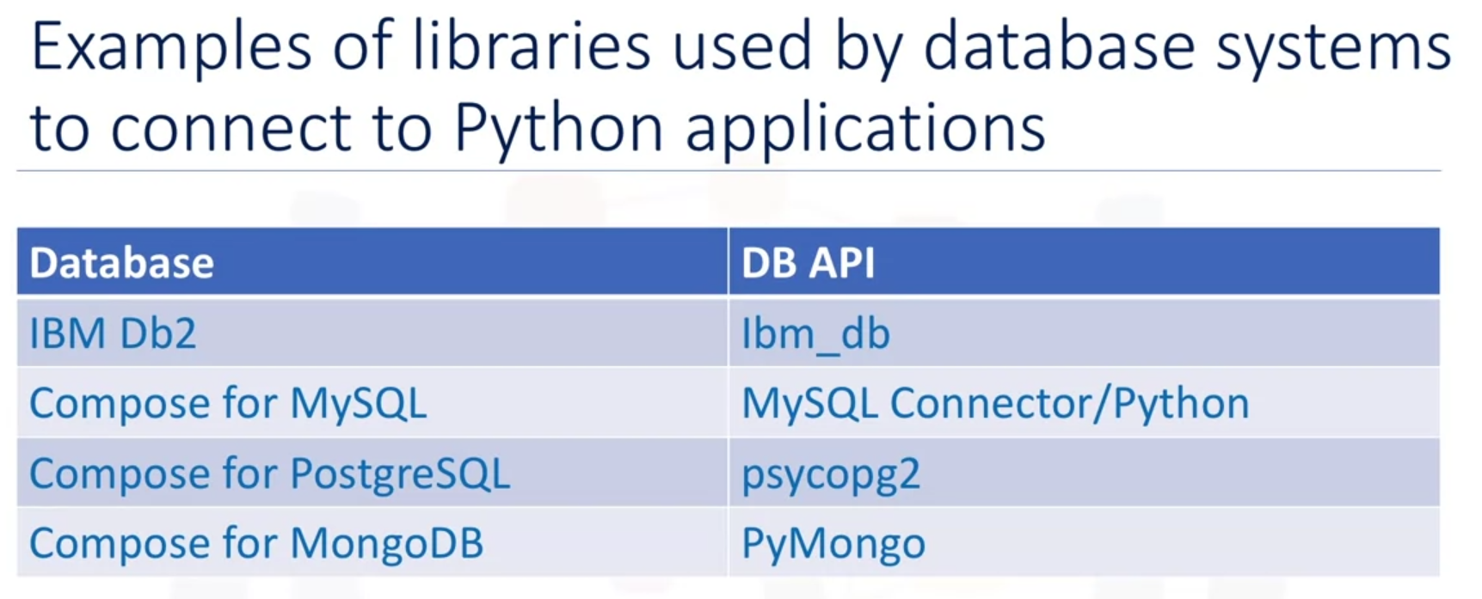

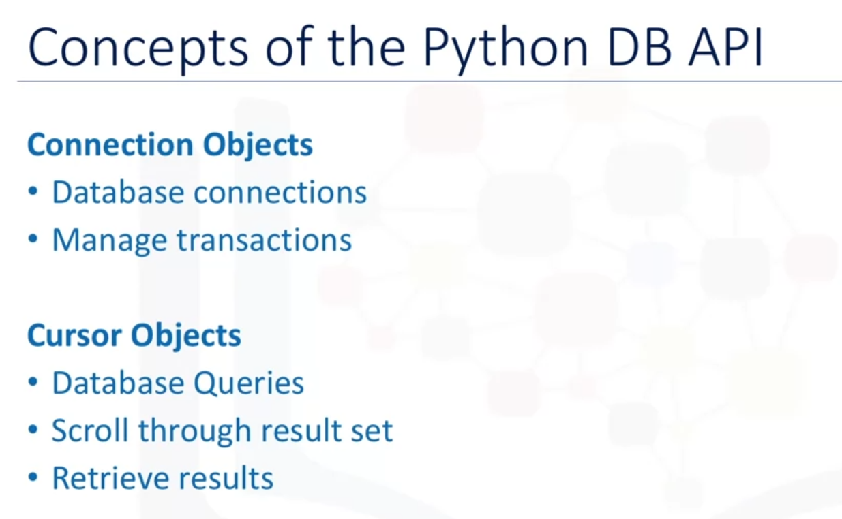

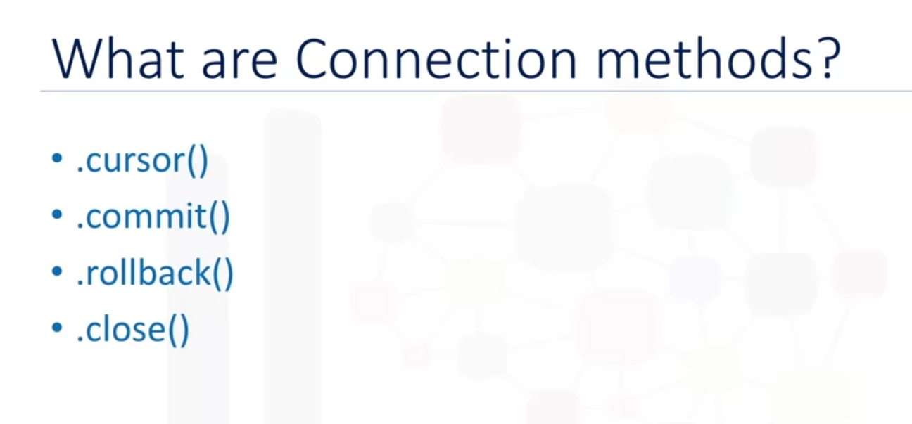

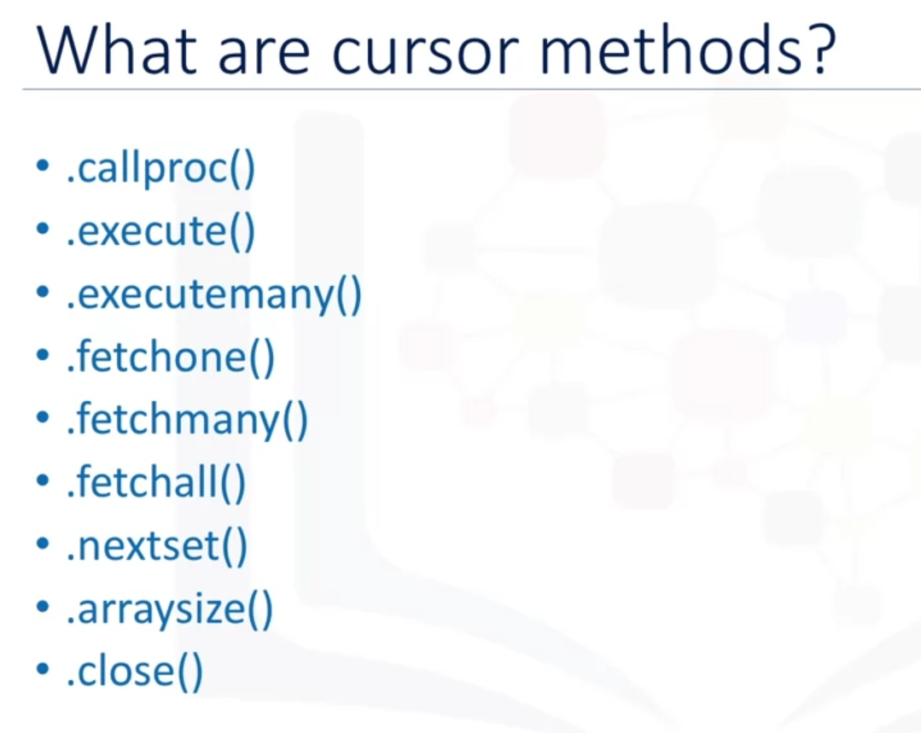

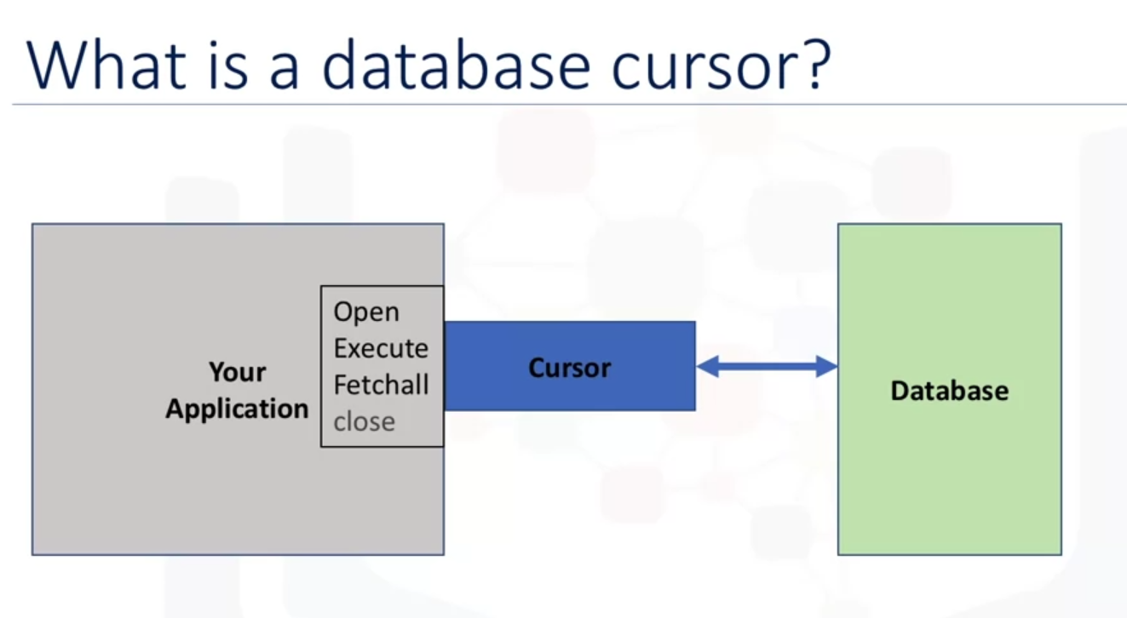

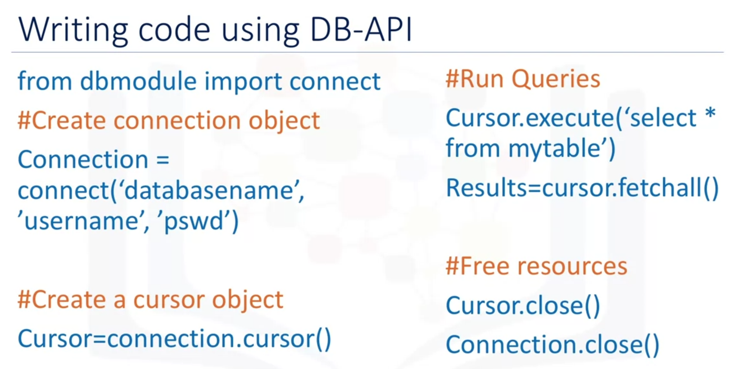

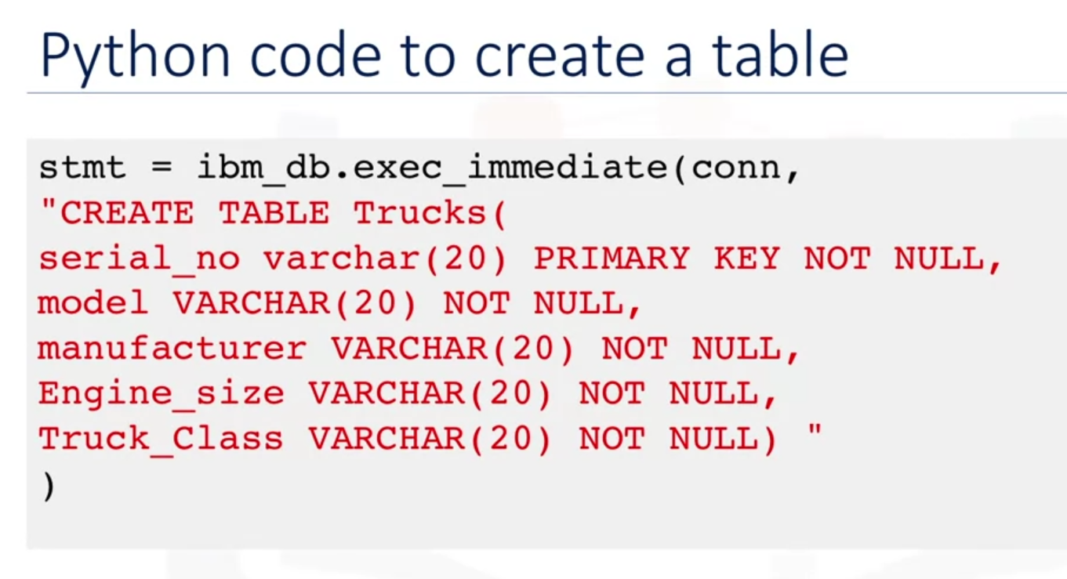

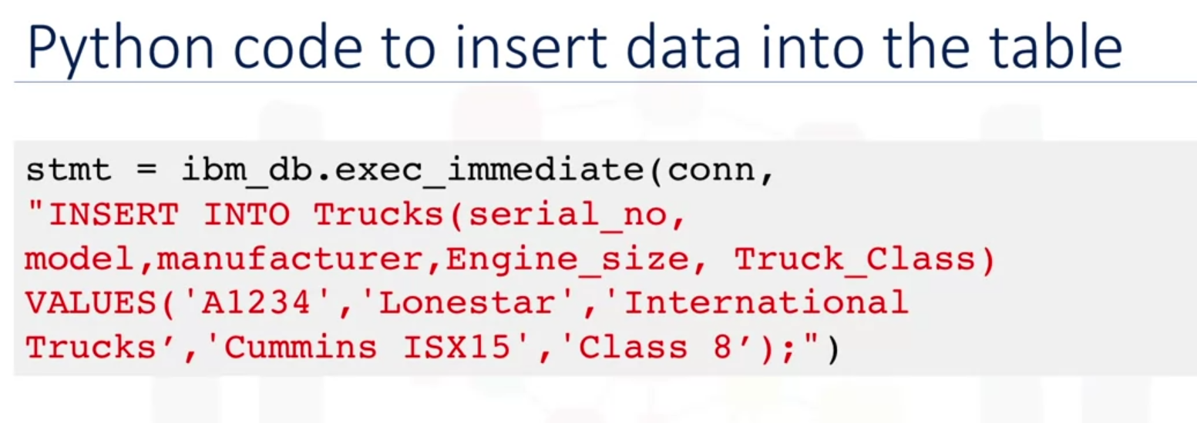

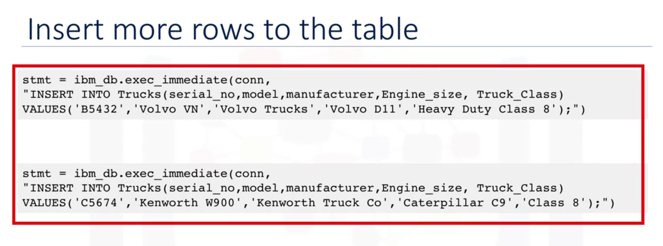

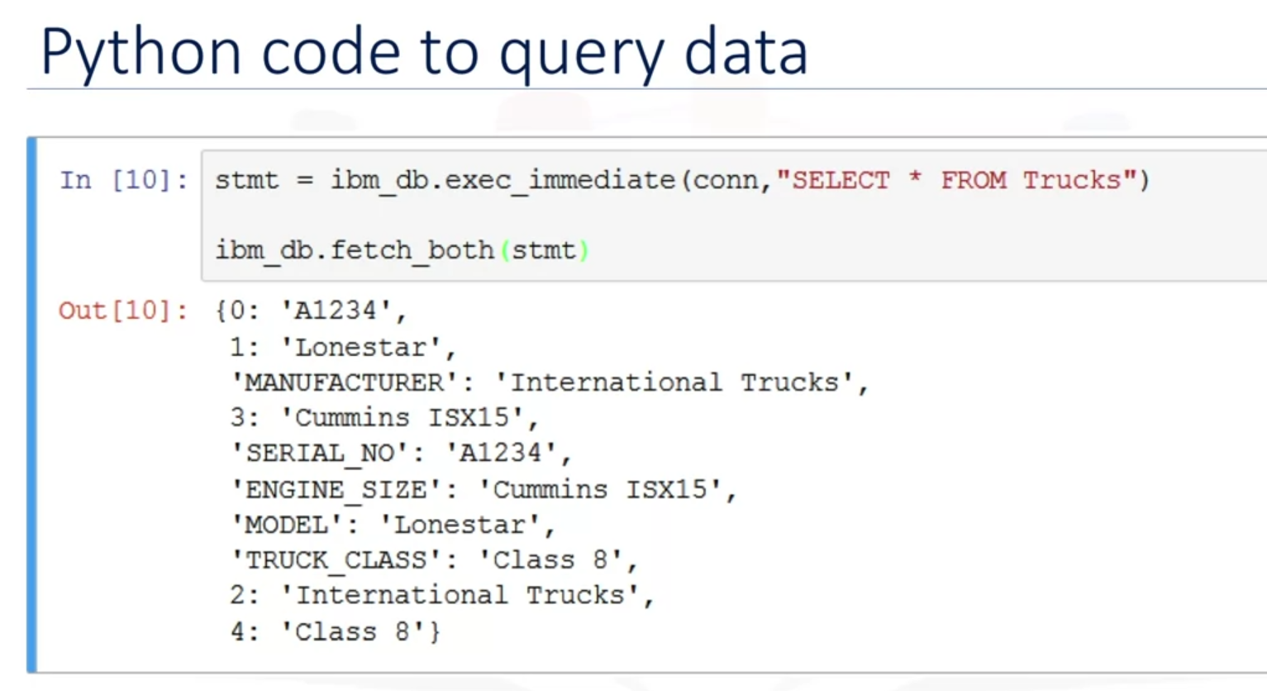

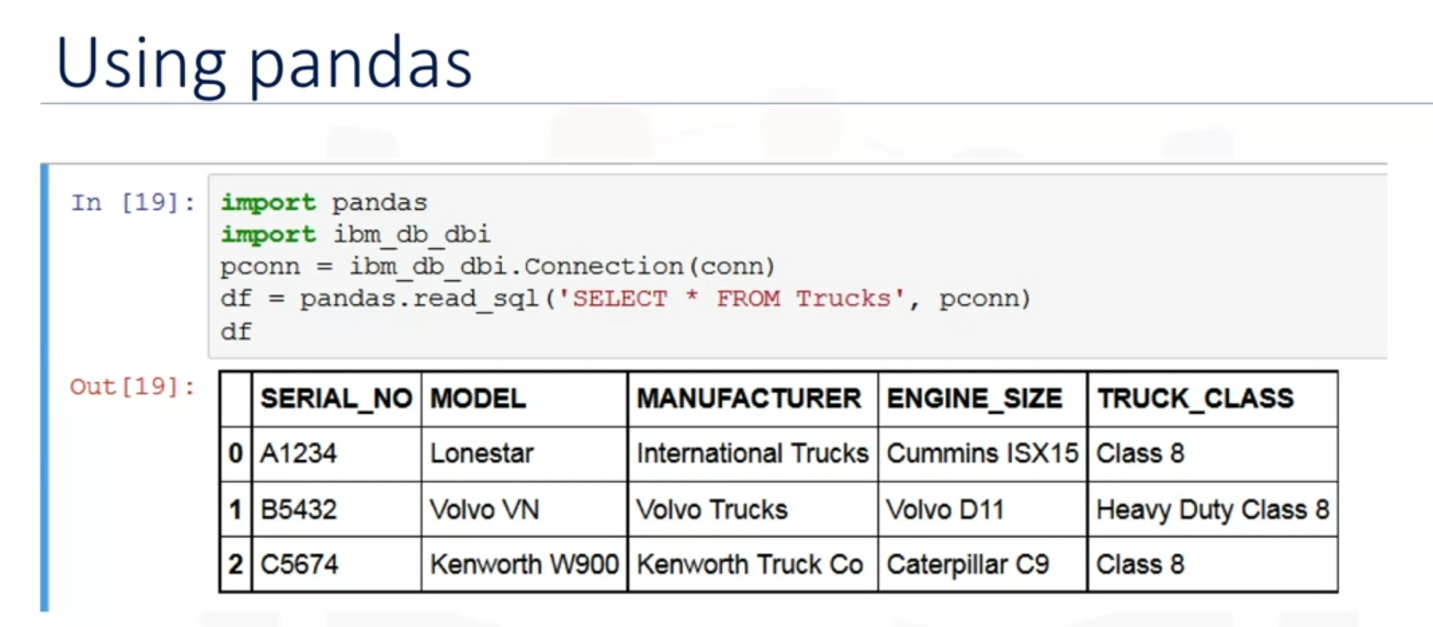

# Summary & Highlights

Congratulations! You have completed this lesson. At this point in the course, you know:

* You can access a database from a language like Python by using the appropriate API. Examples include ibm_db API for IBM DB2, psycopg2 for ProstgreSQL, and dblib API for SQL Server.
* DB-API is Python's standard API for accessing relational databases. It allows you to write a single program that works with multiple kinds of relational databases instead of writing a separate program for each one.
* The DB_API connect constructor creates a connection to the database and returns a Connection Object, which is then used by the various connection methods.
* The connection methods are: The cursor() method, which returns a new cursor object using the connection. The commit() method, which is used to commit any pending transaction to the database. The rollback() method, which causes the database to roll-back to the start of any pending transaction. The close() method, which is used to close a database connection.
* You can use **SQL Magic** commands to execute queries more easily from Jupyter Notebooks. Magic commands have the general format **%sql select * from tablename**. **Cell magics** start with a double %% (percent) sign and apply to the entire cell. **Line magics** start with a single % (percent) sign and apply to a particular line in a cell.

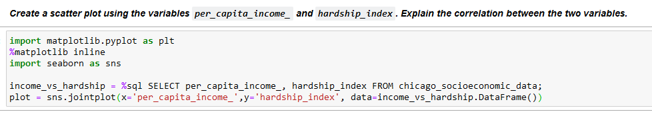

# if the import command gives ModuleNotFoundError: No module named 'seaborn'

# then uncomment the following line i.e. delete the # to install the seaborn package

# !pip install seaborn



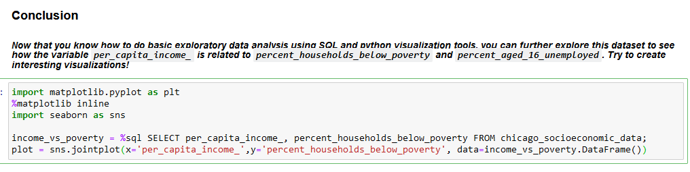

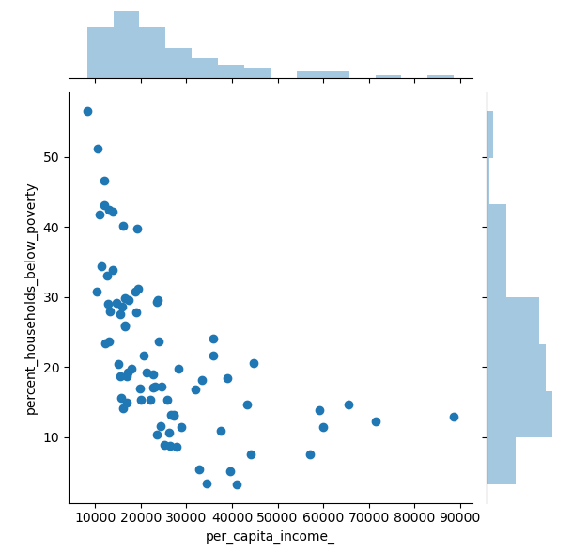

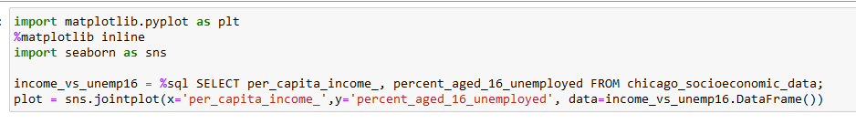

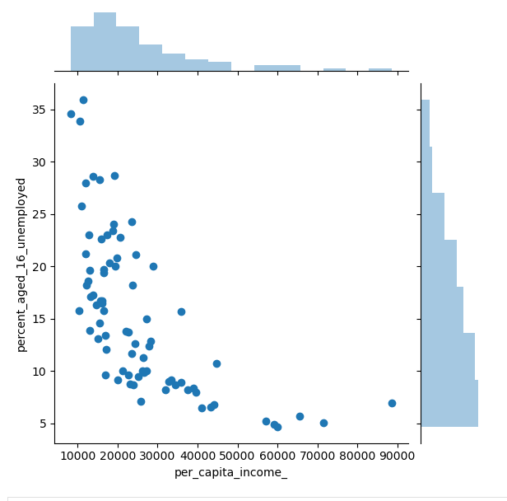

**Week 5**

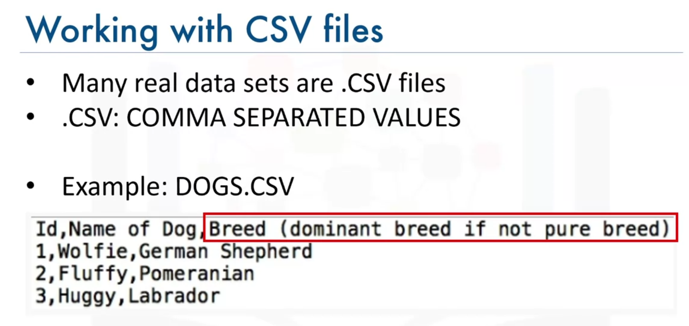

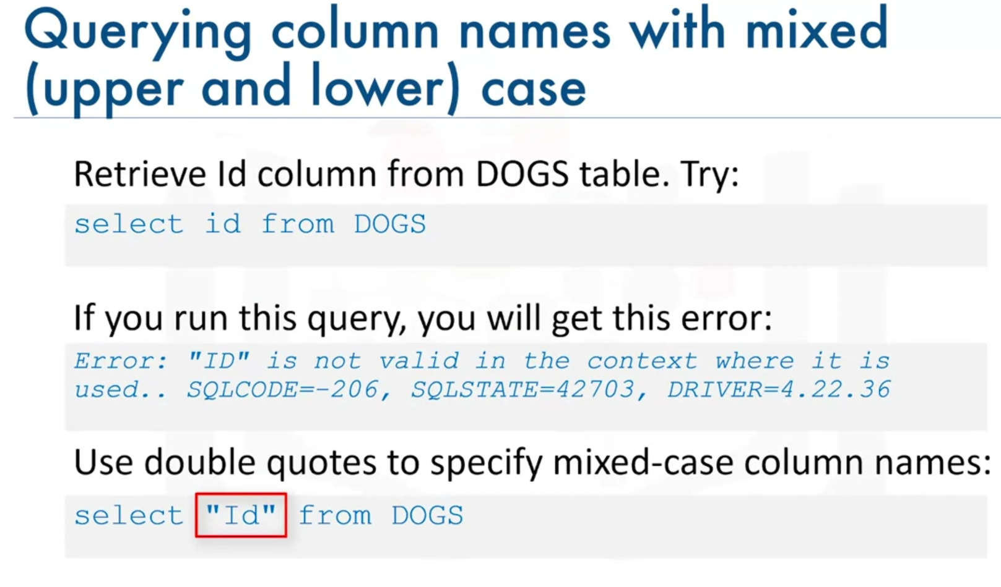

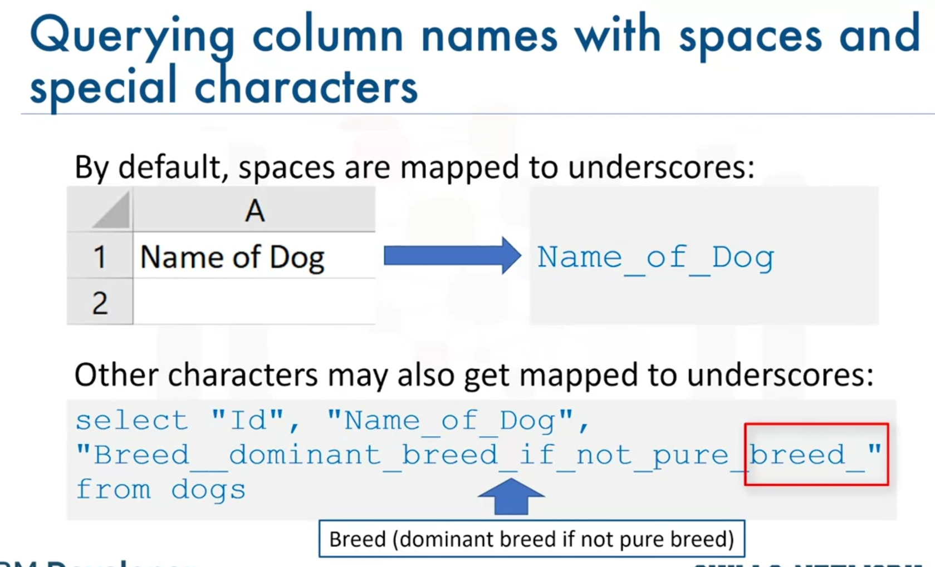

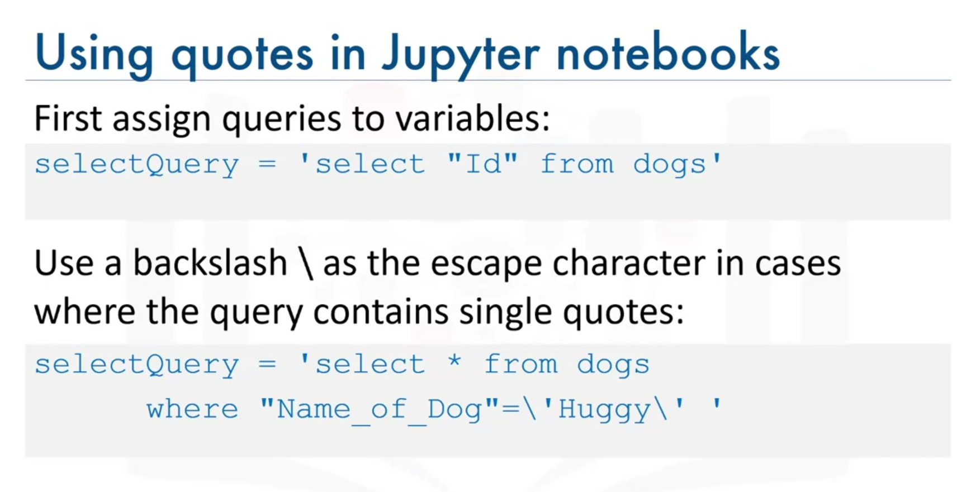

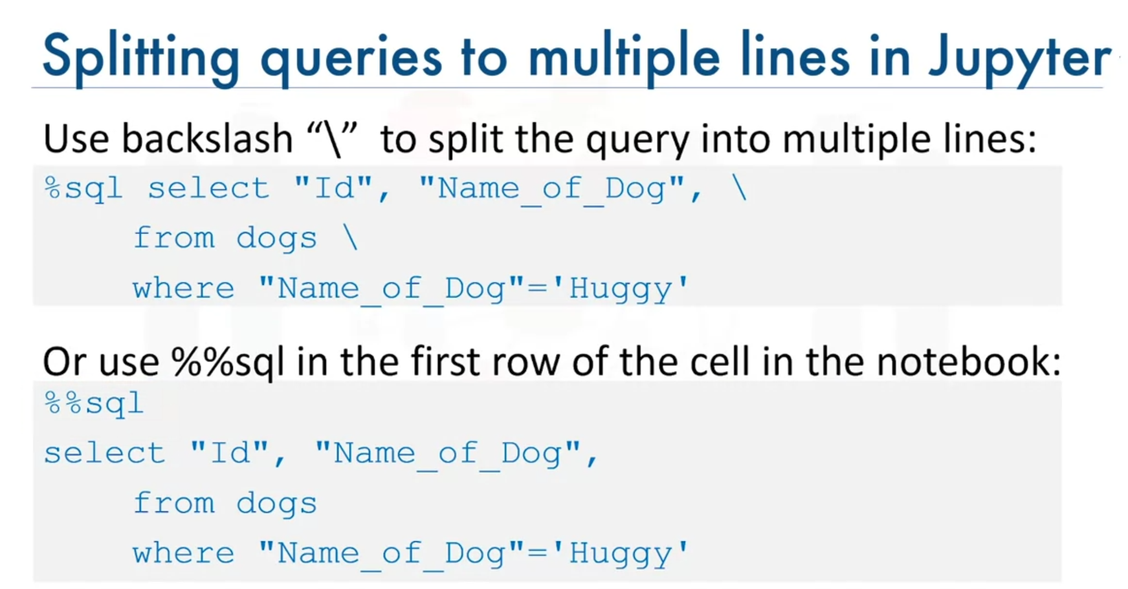

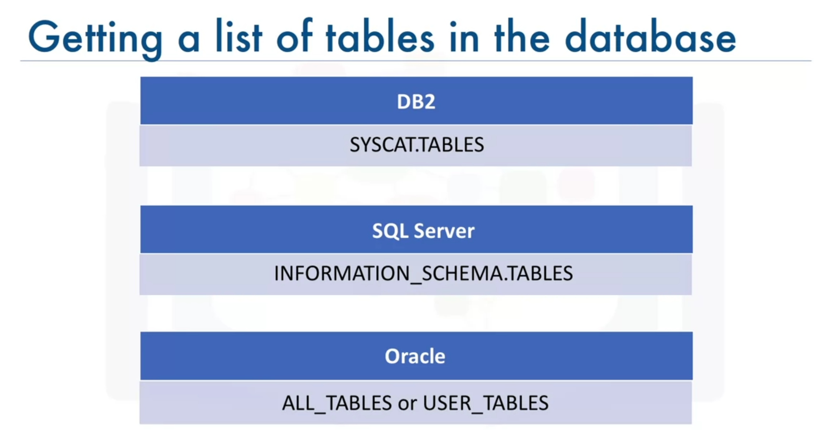

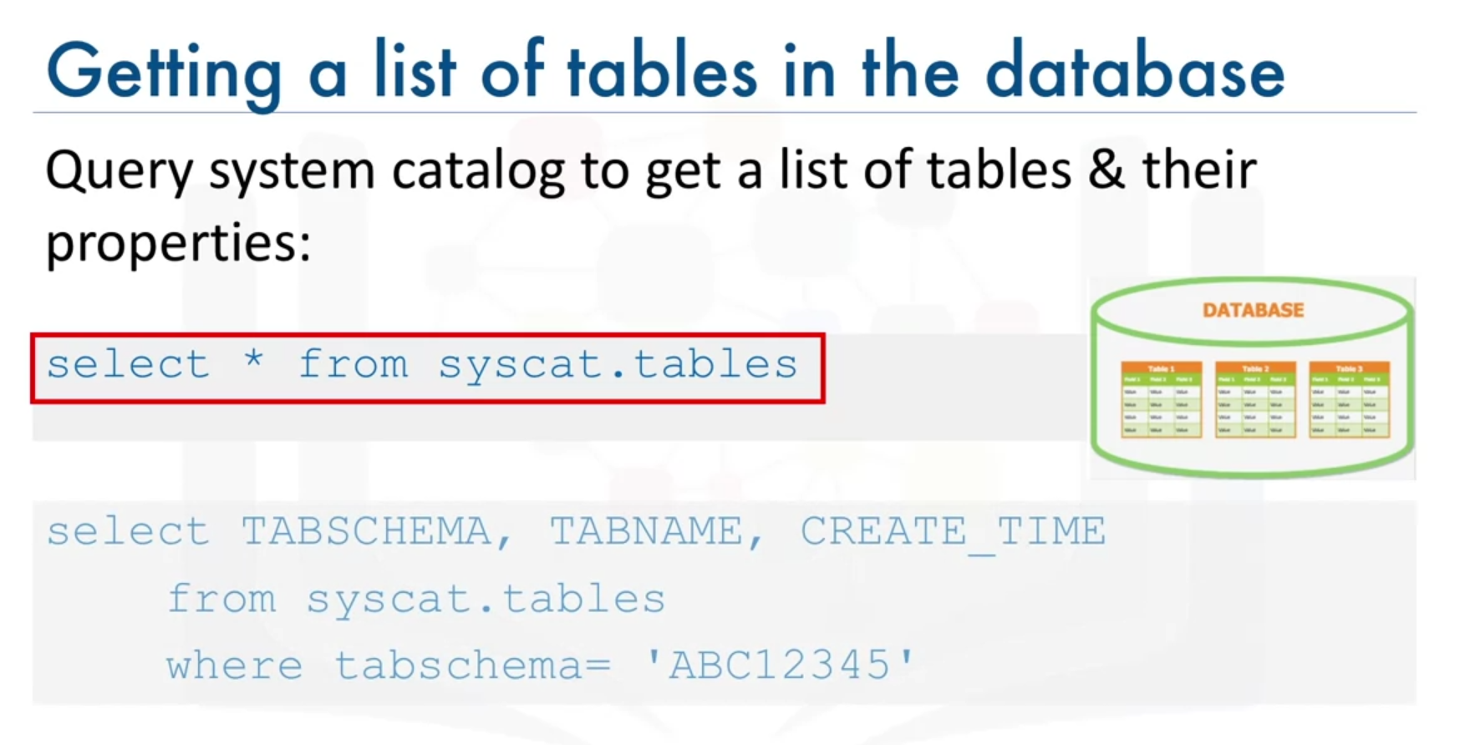

Where *abc12345* is your own username.

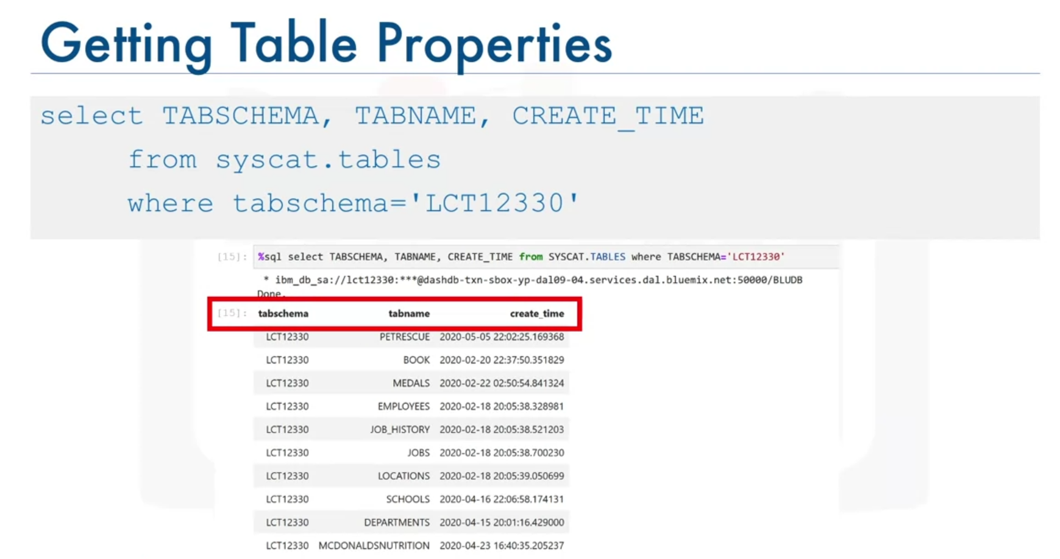

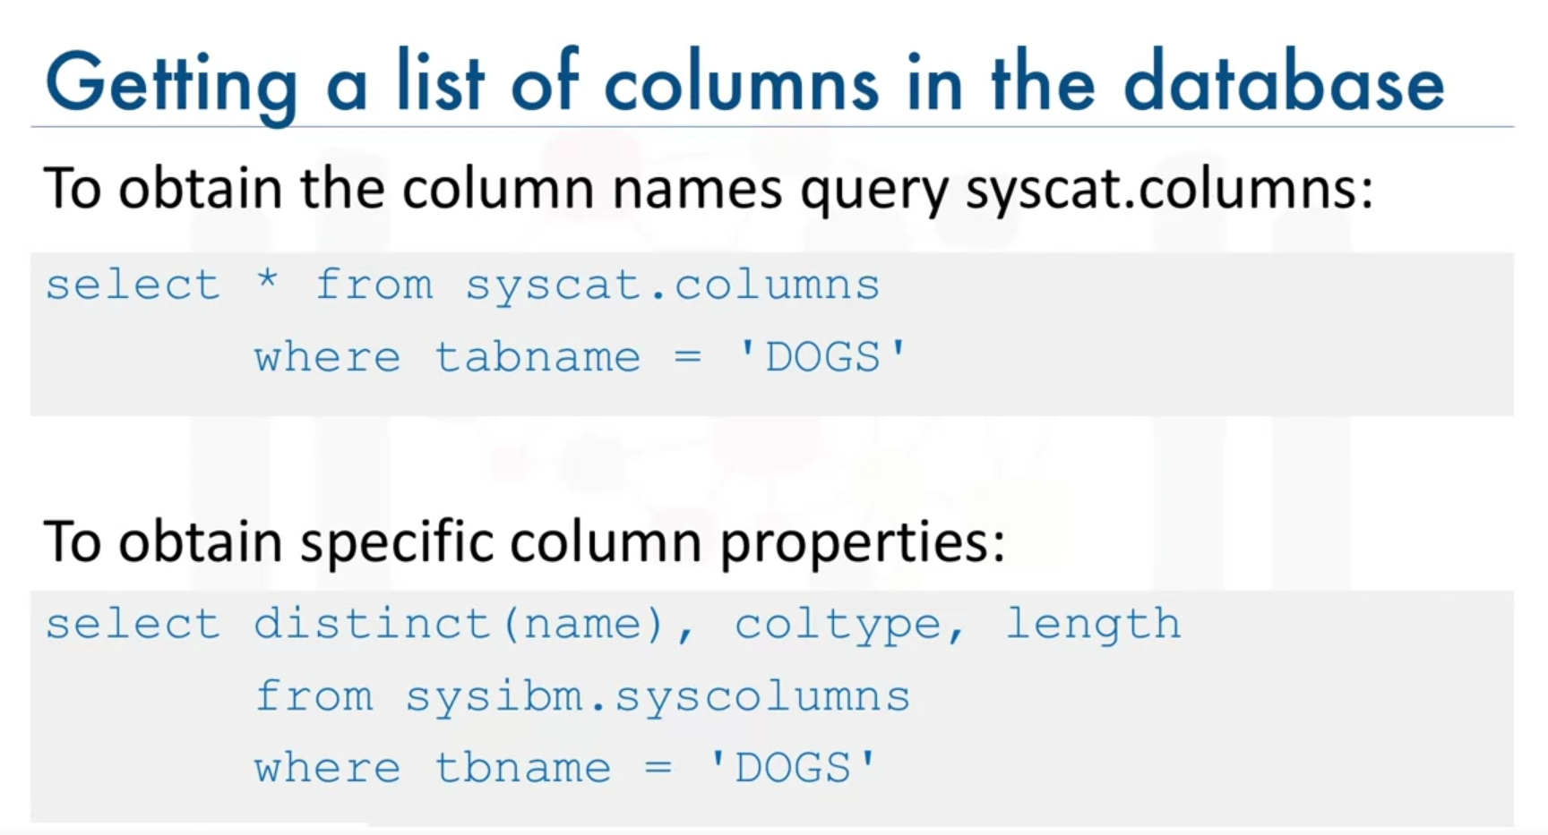

For your information, in MySQL, you can simply run the command SHOW COLUM from dogs,

or you may want to know specific properties like the datatype and length of the datatype.

